**Accessing IBM DB2 Database using Python**



There are various ways of accessing databases such as JDBC, JavaScript, JSP, Python and many others. Here, we will be specifically talking about Python as it is a quite popular scripting language for connecting to databases.

**Why Python ?**

The Python ecosystem is very rich and provides easy to use tools for data science. Some of the most popular packages are NumPy, Pandas, Matplotlib, and SciPy. Python is easy to learn and has a simple syntax. As it is open source, it has been ported to many platforms. Python code to access databases has been made easier by the presence of Python Database API.

We will also be using Jupyter Notebook to create documents that contain live code, equations, visualizations and narrative text.

**How are we going to access the databases ?**

You must be thinking about how we are going to access the databases.

There is a mechanism through which Python contacts the DBMS, it connects to the DBMS with the help of API calls.

The application program begins accessing the DBMS by one or more API calls that connect the program to the database. The program builds the query statement as a text string in a buffer and then makes an API call to send the buffer contents to the database, in this way we can modify the database.

After that the program makes an API call to check the status of the database and to handle errors. The access to the database is finished when an API call is made to disconnect it from the database.

For better understanding, the basic functioning of an API or Application Program Interface is given in the below figure.

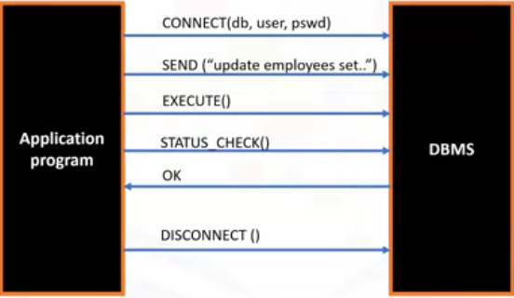

Interface between API and Database

The different types of API used by popular SQL — based DBMS systems.

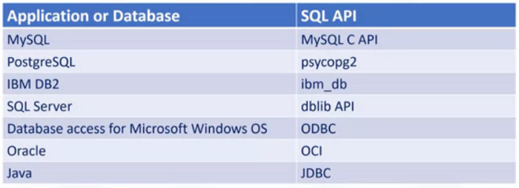

Database along with their API

Here, we are going to use ibm_db SQL API and IBM DB2 database.

**Let’s get started…**

In order to use the IBM DB2 DBMS, you have to make a IBM cloud account. There is an IBM DB2 Lite plan that is free to use.

Go to this link : [*https://cloud.ibm.com/registration*](https://cloud.ibm.com/registration) to make an IBM cloud account.

After logging in your IBM cloud account. You will notice a catalog option on the top just to the left of the search bar available on the webpage.

After going in the catalog you will see the webpage given below.

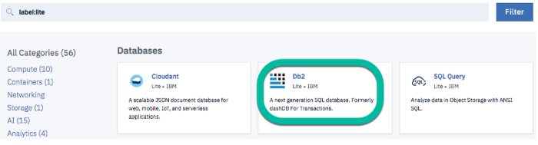

Make sure you choose DB2 and nothing else such as DB2 Warehouse, DB2 Hosted or SQL Query.

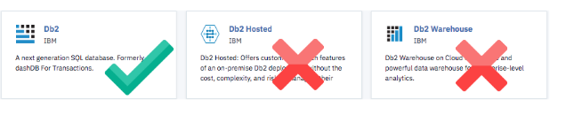

After that everything will be pre — selected, you just have to move down to Pricing Plans and select the Lite plan as it is a free plan.

Then click on the Create at the bottom right of the page.

After that open your dashboard in the IBM cloud.

Now on the right side of the webpage you will see a Resource List option. After going in the Resource List, locate and expand the Services and click on your instance of DB2 database.

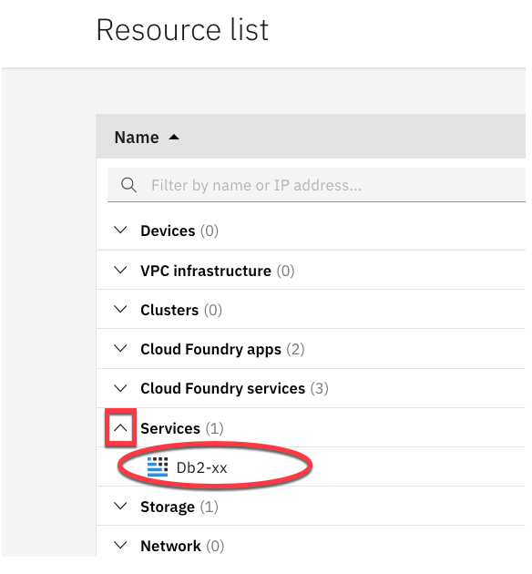

After that click on the open console button. This will open a new tab on your web browser and then choose the 3rd option from the top left drop down menu, now if you want to run SQL queries. You can do it from here.

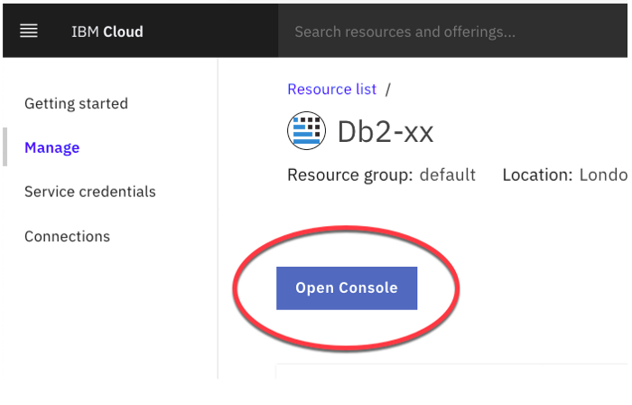

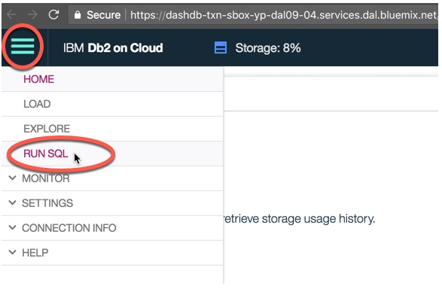

We need to have Service Credentials in order to access the database from Python. So, you have to go to the web page where there is an Open Console button.

On the left side you can see the Service Credentials option. Click on that button and then click on the New Credentials button to generate Service Credentials for your IBM DB2 Database.

We will need the credentials later on.

**Starting with the Python Code**

First of all you need to download the python library ibm_db.

You can see how to download ibm_db library here : [*https://pypi.org/project/ibm-db/*](https://pypi.org/project/ibm-db/)

After that you have to import ibm_db in the jupyter notebook.



The credentials that you will be needing to connect to the database are as follows :

1. Driver Name
2. Database Name
3. Host DNS name or IP Address
4. Host Port
5. Connection Protocol
6. Username
7. Password

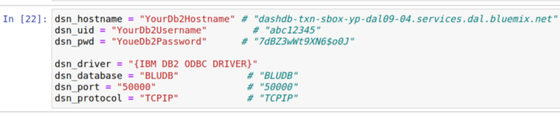

The dsn_driver will remain the same. Others may change, so you have to refer to the credentials in order to replace the values.

The ibm_db API uses the IBM Data Server Driver for Open Database Connectivity and Command Line Interface API’s to connect to the IBM DB2 database.

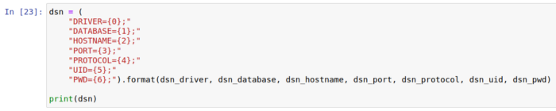

You have to print the results in order to check if the details are correct.

Now the next step is to establish a connection to the database.

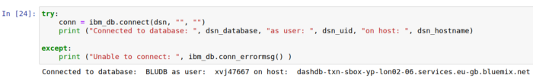

You can also retrieve the metadata from the Database server.

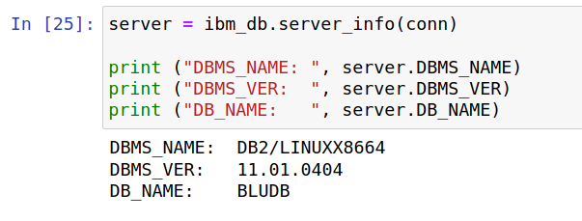

We will create a table in our database with the following database :

The name of the table will be CARTOON_CHARACTERS.

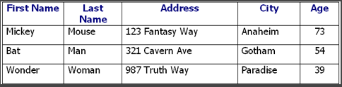

First of all we will give the query to create the above table.



Here, ibm_db.exec_immediate() is the function that will send the query to your IBM database and create changes in the database.

Now we will insert all the data into the database.



After inserting the data into the database we will check if the table in the data has been modified or not, so we will run the following command.

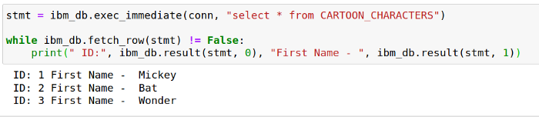

Now, the best thing about accessing databases through python is that you can load the database into Pandas data frame and you can use all the data science tools on the database using all the Python data science libraries.

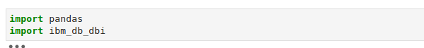

Now we have to establish a connection for the pandas.



After establishing the connection, now we can load the database into the pandas data frame.

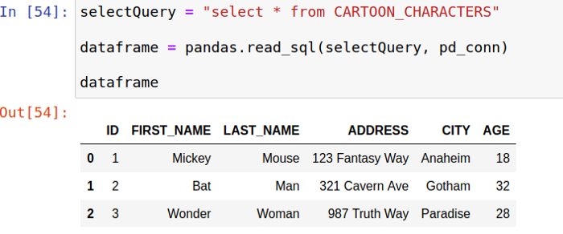

Now you can do the typical pandas operations on the database.

For example, you can use the shape function of the pandas.

